Wallpapers of Kerala's nature.

Keralas backwaters,lagoons,punchapaadams,temples and all other beautiful pics.Nature wallpapers of kerala.

Now Sundharakeralam is available at [www.mykerala.tk](http://www.mykerala.tk)

[http://img1.blogblog.com/img/icon18_wrench_allbkg.png](http://www.blogger.com/rearrange?blogID=1911505810595654054&widgetType=Text&widgetId=Text1&action=editWidget)

[Incredible India](http://sundharakeralam.blogspot.com/2010/06/incredible-india.html)

[http://img1.blogblog.com/img/icon18_email.gif](http://www.blogger.com/email-post.g?blogID=1911505810595654054&postID=7111947274513226523)[http://img2.blogblog.com/img/icon18_edit_allbkg.gif](http://www.blogger.com/post-edit.g?blogID=1911505810595654054&postID=7111947274513226523)[Links to this post](http://sundharakeralam.blogspot.com/2010/06/incredible-india.html#links) Categories [Landscapes](http://sundharakeralam.blogspot.com/search/label/Landscapes), [Rivers](http://sundharakeralam.blogspot.com/search/label/Rivers), [Sea](http://sundharakeralam.blogspot.com/search/label/Sea), [Valley](http://sundharakeralam.blogspot.com/search/label/Valley) [0 comments](http://sundharakeralam.blogspot.com/2010/06/incredible-india.html#comments)

Posted by Saran

|  |  |
| --- | --- |
| Reactions: |  |

[An Island!](http://sundharakeralam.blogspot.com/2009/12/island.html)

[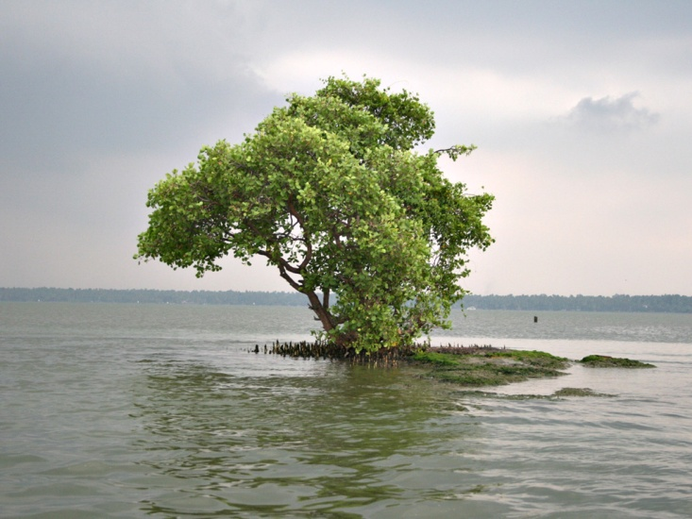](http://farm1.static.flickr.com/108/315649818_a821717d0c_o.jpg)

An island near neendakara,Chavara!

[http://img1.blogblog.com/img/icon18_email.gif](http://www.blogger.com/email-post.g?blogID=1911505810595654054&postID=85351163903633405)[http://img2.blogblog.com/img/icon18_edit_allbkg.gif](http://www.blogger.com/post-edit.g?blogID=1911505810595654054&postID=85351163903633405)[Links to this post](http://sundharakeralam.blogspot.com/2009/12/island.html#links) Categories [Chavara](http://sundharakeralam.blogspot.com/search/label/Chavara), [Landscapes](http://sundharakeralam.blogspot.com/search/label/Landscapes), [Rivers](http://sundharakeralam.blogspot.com/search/label/Rivers) [0 comments](http://sundharakeralam.blogspot.com/2009/12/island.html#comments)

Posted by Saran

|  |  |
| --- | --- |
| Reactions: |  |

[Boats...Houseboats...](http://sundharakeralam.blogspot.com/2009/12/boatshouseboats.html)

[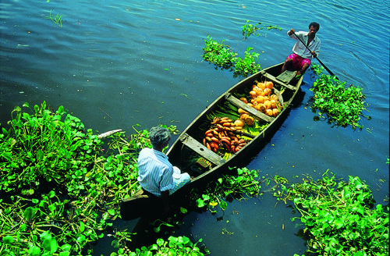](http://farm3.static.flickr.com/2536/3817472889_e755801825.jpg)

A boat in the backwaters..

[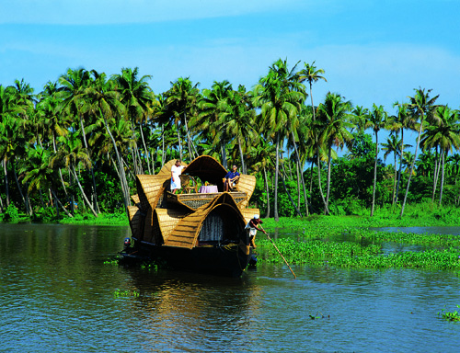](http://farm3.static.flickr.com/2671/3817472585_e647e76587.jpg)

[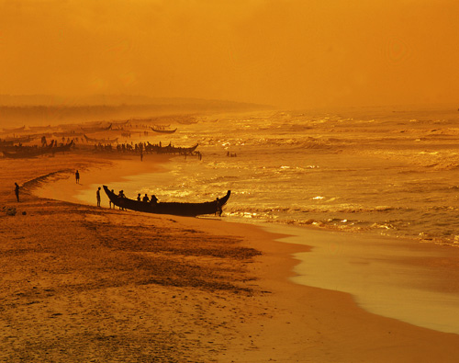](http://farm3.static.flickr.com/2545/3817476559_c7499cebff.jpg)

[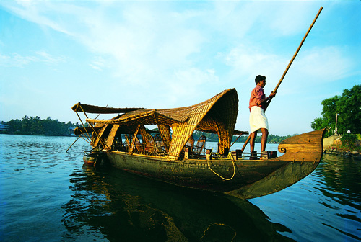](http://farm3.static.flickr.com/2598/3817473275_5e3c9c3fe0.jpg)

[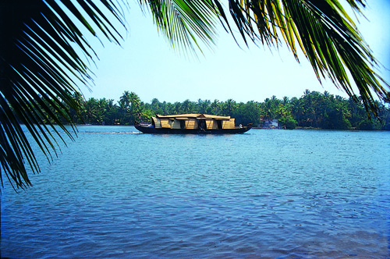](http://farm3.static.flickr.com/2494/3818283524_57f8e2d146.jpg)

[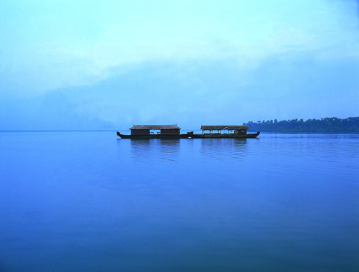](http://farm4.static.flickr.com/3497/3817470927_7cd87ecddf.jpg)

Two houseboats!

[http://img1.blogblog.com/img/icon18_email.gif](http://www.blogger.com/email-post.g?blogID=1911505810595654054&postID=6124892259294963739)[http://img2.blogblog.com/img/icon18_edit_allbkg.gif](http://www.blogger.com/post-edit.g?blogID=1911505810595654054&postID=6124892259294963739)[Links to this post](http://sundharakeralam.blogspot.com/2009/12/boatshouseboats.html#links) Categories [Rivers](http://sundharakeralam.blogspot.com/search/label/Rivers) [1 comments](http://sundharakeralam.blogspot.com/2009/12/boatshouseboats.html#comments)

Posted by Saran

|  |  |
| --- | --- |
| Reactions: |  |

[Kallar,Thiruvananthapuram...](http://sundharakeralam.blogspot.com/2009/12/kallarthiruvananthapuram.html)

Source:http://www.flickr.com/photos/keralatourism/

[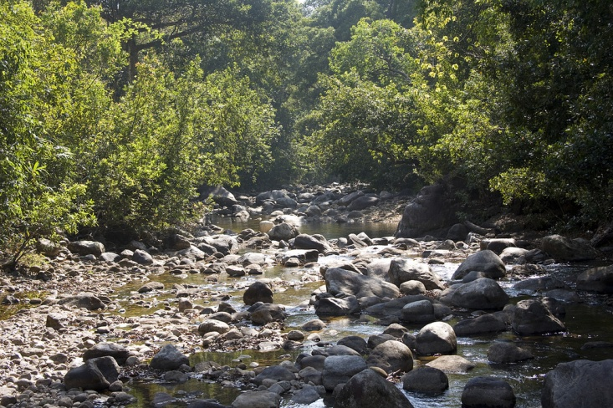](http://farm3.static.flickr.com/2439/4182518150_291ce05c28_b.jpg)

[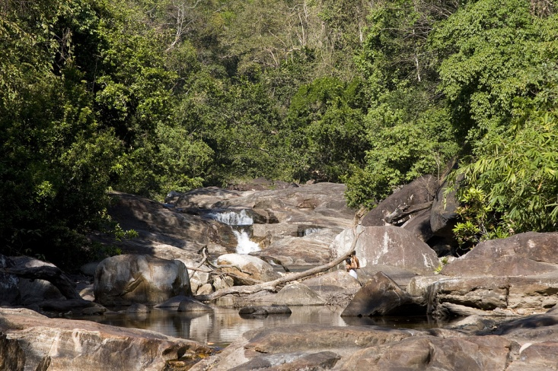](http://farm5.static.flickr.com/4043/4182517506_b8b6ac21d9_b.jpg)

Kallar is small town in Thiruvananthapuram district in Kerala, India. Kallar is 45 km from Thiruvananthapuram, while the town of Ponmudi is a further 15 km away. The majestic Vamanapuram River flows through the town. Torrential rain can raise the level of the river and sweep away things that come in its way; recently, several dental college students of Trivandrum lost their lives in flash floods. Many varieties of birds and trees can be also be seen in and around Kallar.

[http://img1.blogblog.com/img/icon18_email.gif](http://www.blogger.com/email-post.g?blogID=1911505810595654054&postID=5237815175796723933)[http://img2.blogblog.com/img/icon18_edit_allbkg.gif](http://www.blogger.com/post-edit.g?blogID=1911505810595654054&postID=5237815175796723933)[Links to this post](http://sundharakeralam.blogspot.com/2009/12/kallarthiruvananthapuram.html#links) Categories [Kallar](http://sundharakeralam.blogspot.com/search/label/Kallar), [Landscapes](http://sundharakeralam.blogspot.com/search/label/Landscapes), [Rivers](http://sundharakeralam.blogspot.com/search/label/Rivers) [0 comments](http://sundharakeralam.blogspot.com/2009/12/kallarthiruvananthapuram.html#comments)

Posted by Saran

|  |  |
| --- | --- |
| Reactions: |  |

[Chinnar wildlife Sanctuary.](http://sundharakeralam.blogspot.com/2009/12/chinnar-wildlife-sanctuary.html)

Source:http://www.flickr.com/photos/keralatourism/

[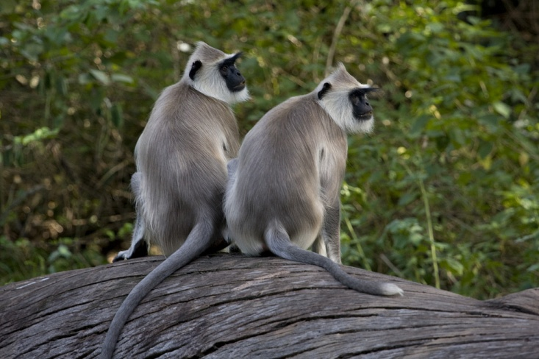](http://farm5.static.flickr.com/4038/4182531906_6ee5b43b0c_b.jpg)

[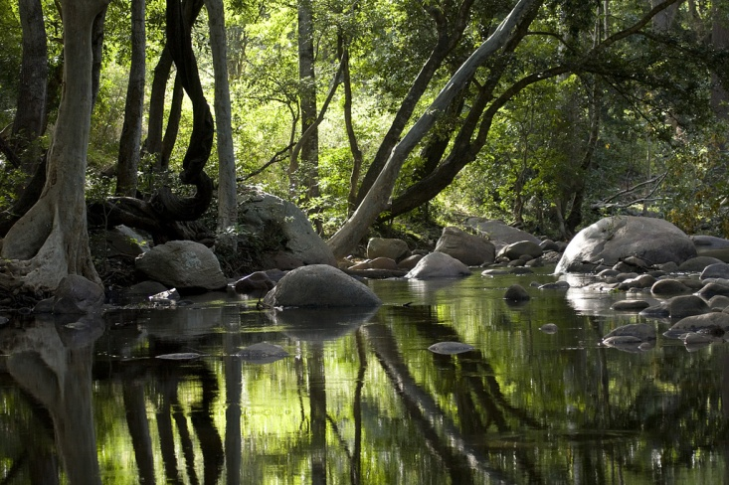](http://farm5.static.flickr.com/4043/4181769319_2faa68a4c2_b.jpg)

[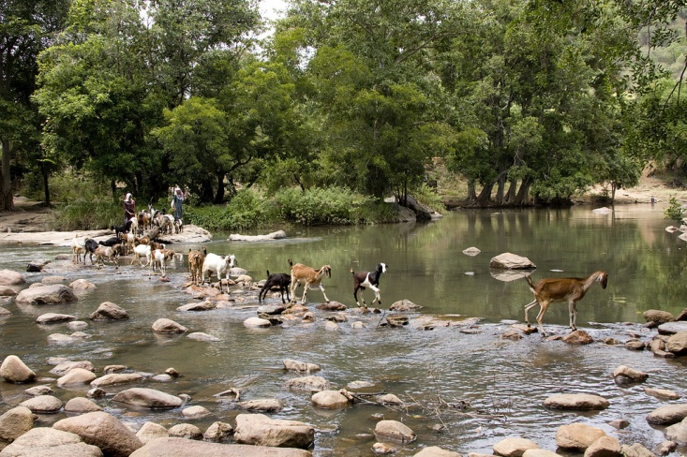](http://farm3.static.flickr.com/2565/4181770725_a8b61c8a72_b.jpg)

Chinnar Wildlife Sanctuary, (CWS), is located 18 km north of Marayoor on SH 17 in the Marayoor and Kanthalloor Panchayats ofDevikulam Taluk in the Idukki district of Kerala state in South India. It is one of twelve Wildlife Sanctuaries among the Protected areas of Kerala.  
  
It is under the jurisdiction of and contiguous with Eravikulam National Park to the south. Indira Gandhi Wildlife Sanctuary is to the north and Kodaikanal Wildlife Sanctuary is to the east. It forms an integral part of the 1,187 km2 (458 sq mi) block of protected forests straddling the Kerala-Tamil Nadu border in the Annamalai Hills. The Western Ghats, Anamalai Sub-Cluster, including all of Chinnar Wildlife Sanctuary, is under consideration by the UNESCO World Heritage Committee for selection as a World Heritage Site.

[http://img1.blogblog.com/img/icon18_email.gif](http://www.blogger.com/email-post.g?blogID=1911505810595654054&postID=3581900522179755899)[http://img2.blogblog.com/img/icon18_edit_allbkg.gif](http://www.blogger.com/post-edit.g?blogID=1911505810595654054&postID=3581900522179755899)[Links to this post](http://sundharakeralam.blogspot.com/2009/12/chinnar-wildlife-sanctuary.html#links) Categories [Chinnar](http://sundharakeralam.blogspot.com/search/label/Chinnar), [Landscapes](http://sundharakeralam.blogspot.com/search/label/Landscapes), [Rivers](http://sundharakeralam.blogspot.com/search/label/Rivers), [Wildlife](http://sundharakeralam.blogspot.com/search/label/Wildlife) [0 comments](http://sundharakeralam.blogspot.com/2009/12/chinnar-wildlife-sanctuary.html#comments)

Posted by Saran

|  |  |
| --- | --- |
| Reactions: |  |

[Thekkady Elephants!!!](http://sundharakeralam.blogspot.com/2009/12/thekkady-elephants.html)

Source:http://www.flickr.com/photos/keralatourism/

[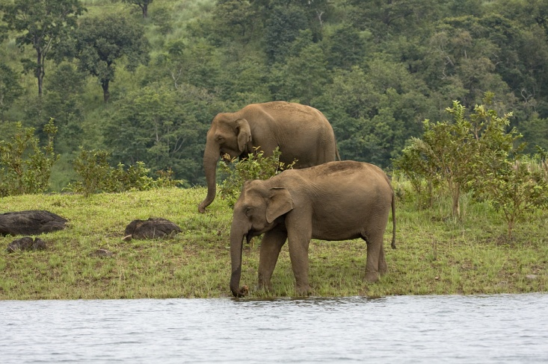](http://farm3.static.flickr.com/2632/4182358386_e7999f7875_b.jpg)

[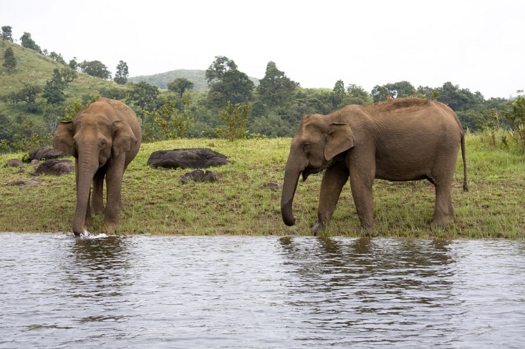](http://farm3.static.flickr.com/2653/4181596001_47d9ac56fd_b.jpg)

[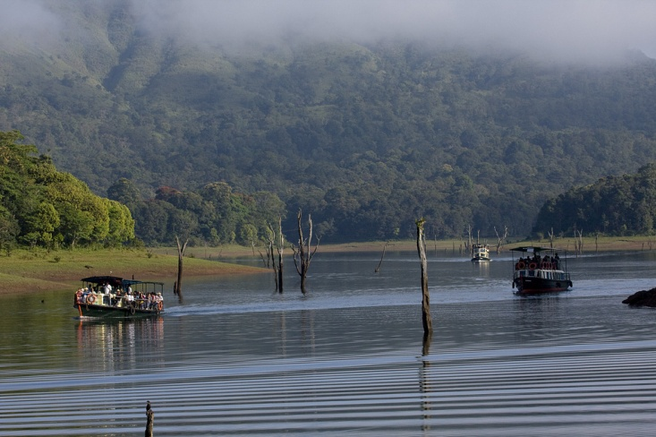](http://farm3.static.flickr.com/2795/4181596499_3e4998d663_b.jpg)

[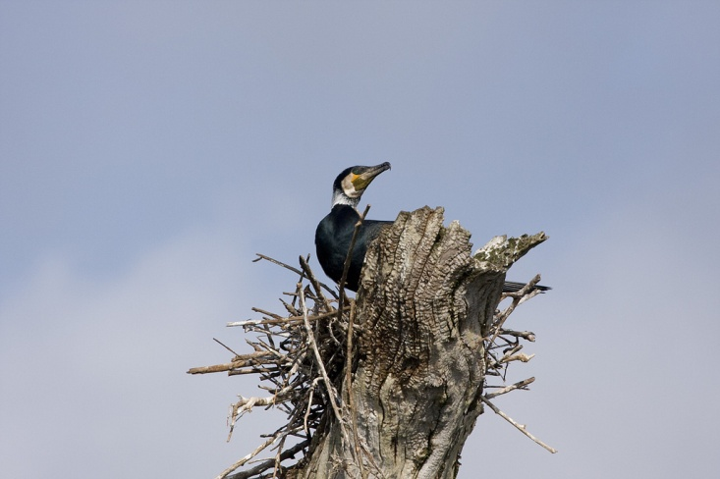](http://farm3.static.flickr.com/2515/4182359536_4c9f4c4656_b.jpg)

[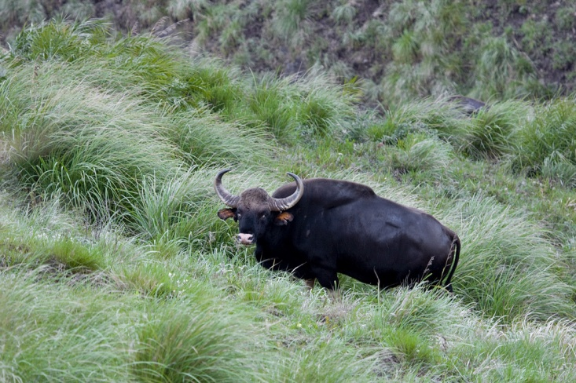](http://farm3.static.flickr.com/2510/4182507166_829d4d1022_b.jpg)

Situated in kerala, close to the Kerala - Tamil Nadu border town - Kumily, it is located about 257 km (160 miles) from Trivandrum, 114 km from Madurai Airport, 185 km from Cochin International Airport and 114 km from Kottayam railway station. The sanctuary is famous for its dense evergreen, semi-evergreen, moist deciduous forestsand savanna grass lands. It is home to herds of elephants, sambar, tigers, gaur, lion-tailed Macaques and Nilgiri Langurs.  
  
The Periyar Wildlife sanctuary is spread across 777 km² (300 sq. miles), of which 360 km² (139 sq. miles) is thick evergreen forest. The Wild Life Sanctuary was declared a Tiger Reserve in 1978. The splendid artificial lake formed by the Mullaiperiyar Dam across the Periyar River adds to the charm of the park. The greatest attraction of Periyar are the herds of wild elephants that come down to play in the lake.  
  
Thekkady is considered a heaven for natural spices such as black pepper, cardamom, cinnamon and clove.

[http://img1.blogblog.com/img/icon18_email.gif](http://www.blogger.com/email-post.g?blogID=1911505810595654054&postID=5203275088965906311)[http://img2.blogblog.com/img/icon18_edit_allbkg.gif](http://www.blogger.com/post-edit.g?blogID=1911505810595654054&postID=5203275088965906311)[Links to this post](http://sundharakeralam.blogspot.com/2009/12/thekkady-elephants.html#links) Categories [Landscapes](http://sundharakeralam.blogspot.com/search/label/Landscapes), [Thekkady](http://sundharakeralam.blogspot.com/search/label/Thekkady), [Wildlife](http://sundharakeralam.blogspot.com/search/label/Wildlife) [0 comments](http://sundharakeralam.blogspot.com/2009/12/thekkady-elephants.html#comments)

Posted by Saran

|  |  |
| --- | --- |
| Reactions: |  |

[RAndom wallpapers........](http://sundharakeralam.blogspot.com/2009/07/random-wallpapers.html)

[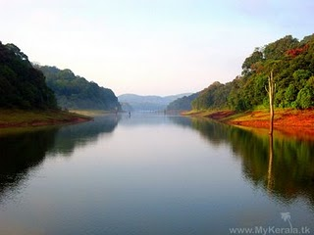](http://4.bp.blogspot.com/_kYa4ADbEv2A/SmbWAj-1_GI/AAAAAAAADN8/UXe_Fq8dFbo/s1600-h/vayanadu.jpg)  
[[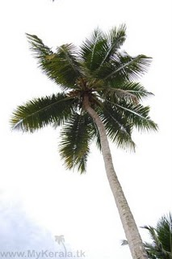](http://4.bp.blogspot.com/_kYa4ADbEv2A/SmbWAWP2TrI/AAAAAAAADN0/9f5zwEr6uRA/s1600-h/thengu.jpg)A](http://4.bp.blogspot.com/_kYa4ADbEv2A/SmbWAWP2TrI/AAAAAAAADN0/9f5zwEr6uRA/s1600-h/thengu.jpg) coconut tree  
[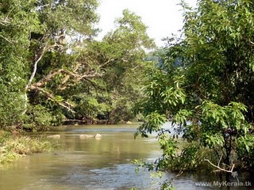](http://2.bp.blogspot.com/_kYa4ADbEv2A/SmbVdh_j3AI/AAAAAAAADNs/_IGljYoQG2w/s1600-h/river.jpg)  
[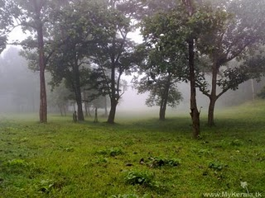](http://1.bp.blogspot.com/_kYa4ADbEv2A/SmbVdda_hJI/AAAAAAAADNk/iulTKqyv4Tk/s1600-h/parambikulam.jpg)  
[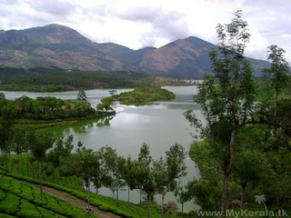](http://3.bp.blogspot.com/_kYa4ADbEv2A/SmbVdK7eSxI/AAAAAAAADNc/SRvqDS5XNPU/s1600-h/munnar.jpg)  
[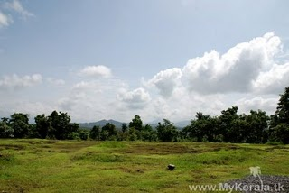](http://1.bp.blogspot.com/_kYa4ADbEv2A/SmbVc4mBNII/AAAAAAAADNU/Mf5NoiafZT8/s1600-h/field.jpg)  
[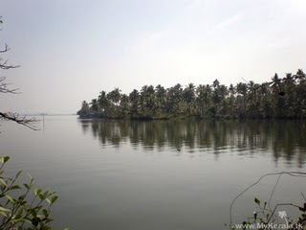](http://4.bp.blogspot.com/_kYa4ADbEv2A/SmbVcS161PI/AAAAAAAADNM/0e4i1huQIGM/s1600-h/backwater.jpg)

[http://img1.blogblog.com/img/icon18_email.gif](http://www.blogger.com/email-post.g?blogID=1911505810595654054&postID=8902498209085910002)[http://img2.blogblog.com/img/icon18_edit_allbkg.gif](http://www.blogger.com/post-edit.g?blogID=1911505810595654054&postID=8902498209085910002)[Links to this post](http://sundharakeralam.blogspot.com/2009/07/random-wallpapers.html#links) Categories [Landscapes](http://sundharakeralam.blogspot.com/search/label/Landscapes), [Paddy field](http://sundharakeralam.blogspot.com/search/label/Paddy%20field), [Periyar](http://sundharakeralam.blogspot.com/search/label/Periyar), [Rivers](http://sundharakeralam.blogspot.com/search/label/Rivers), [Valley](http://sundharakeralam.blogspot.com/search/label/Valley) [0 comments](http://sundharakeralam.blogspot.com/2009/07/random-wallpapers.html#comments)

Posted by Saran

|  |  |
| --- | --- |
| Reactions: |  |

[Neendakara.......Around the bridge....](http://sundharakeralam.blogspot.com/2009/07/neendakaraaround-bridge.html)

[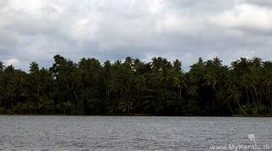](http://4.bp.blogspot.com/_kYa4ADbEv2A/SmbRxGbTXCI/AAAAAAAADNE/Gqfx7yz94Wk/s1600-h/sakthikulangara.jpg)  
[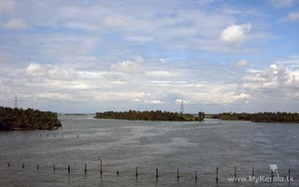](http://1.bp.blogspot.com/_kYa4ADbEv2A/SmbRw7ThZ5I/AAAAAAAADM8/IInj0xnTTvE/s1600-h/neendakara.jpg)  
[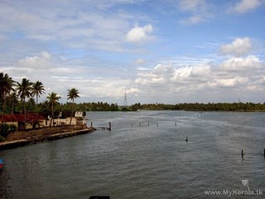](http://4.bp.blogspot.com/_kYa4ADbEv2A/SmbRwluhbnI/AAAAAAAADM0/SWRSj-Bm06s/s1600-h/IMG_0394.jpg)  
[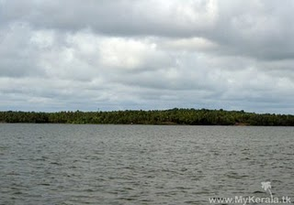](http://1.bp.blogspot.com/_kYa4ADbEv2A/SmbRwfDDiPI/AAAAAAAADMs/JchtjeMhY-E/s1600-h/chavara.jpg)  
Neendakara, a village 8 km north of [Kollam](http://www.india9.com/i9show/-Kerala/Kollam/Kollam-45285.htm), thrives in fishing. It is the headquarters of the Indo-Norwegian fisheries community project established in 1953. The boat building yard at Sakthikulangara, the Fishermen Training Institute, the ice factory and the refrigeration plant comes under this project. Steps are initiated by the Government for establishing a fishing harbor at Neendakara, after considering the unique location and infrastructure available.

Neendakara Port serves as the intermediary port of [Kollam District](http://www.india9.com/i9show/-Kerala/Kollam/Kollam-District-14073.htm) and acts as an important hub of fishing activities. Neendakara Bridge is a famous traveling point, standing on which the stretching backwaters can be seen.

Neendakara lies on the [National Highway 47](http://www.india9.com/i9show/-Kerala/Kollam/National-Highway-47-52338.htm) and the towns of Karunagapally (20 km) and [Kayamkulam](http://www.india9.com/i9show/-Kerala/Kollam/Kayamkulam-20798.htm) (35 km) are north of Neendakara. Inland water navigation is also possible from Neendakara.

[http://img1.blogblog.com/img/icon18_email.gif](http://www.blogger.com/email-post.g?blogID=1911505810595654054&postID=3848835116679137142)[http://img2.blogblog.com/img/icon18_edit_allbkg.gif](http://www.blogger.com/post-edit.g?blogID=1911505810595654054&postID=3848835116679137142)[Links to this post](http://sundharakeralam.blogspot.com/2009/07/neendakaraaround-bridge.html#links) Categories [Chavara](http://sundharakeralam.blogspot.com/search/label/Chavara), [Rivers](http://sundharakeralam.blogspot.com/search/label/Rivers) [0 comments](http://sundharakeralam.blogspot.com/2009/07/neendakaraaround-bridge.html#comments)

Posted by Saran

|  |  |
| --- | --- |
| Reactions: |  |

[Wayand dams n valleys.........](http://sundharakeralam.blogspot.com/2009/07/wayand-dams-n-valleys.html)

[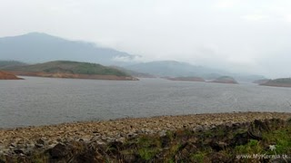](http://1.bp.blogspot.com/_kYa4ADbEv2A/SmbQv-bBZII/AAAAAAAADMk/oekGNSaPTC4/s1600-h/valley+idukki.jpg)  
[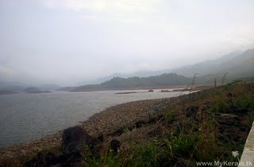](http://1.bp.blogspot.com/_kYa4ADbEv2A/SmbQvshm0pI/AAAAAAAADMc/EMkKQpqilbg/s1600-h/idukku+hills.jpg)  
[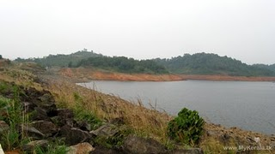](http://1.bp.blogspot.com/_kYa4ADbEv2A/SmbQvdanBCI/AAAAAAAADMU/wWptt0IrLwI/s1600-h/idukki+dam.jpg)  
In a world of sound and fury signifying nothing, an escape to some lively, green, soothing experiences will be quite refreshing as well as rejuvenating. As your vehicle enters Wayanad, the evergreen, idyllic, charming hill district of Kerala, you will be convinced that you have chosen the right place. Located at an altitude ranging from 700 to 2,100 metres above sea level, Wayanad has subtropical savannas, evergreen verdant spice plantations and rolling paddy fields.  
  
This time, let us have a trip to some of the aqua tourism destinations of Wayanad. Kalpetta, the district headquarters of Wayanad is the most convenient and comfortable place to stay back and explore these destinations. If you come via Kozhikode, passing Thamarassery churam, the mountain path, drive 12 more kilometers to reach Kalpetta. This is one of the major towns in Wayanad, the others being Mananthavady and Sultan Bathery. Abundant in tea and coffee plantations, Kalpetta offers good accommodation facilities as well.  
  
Travelling 15 kilometers from Kalpetta, you will reach Pookkot Lake, a perennial fresh water lake, nestled among wooded hills. You can explore this vast, blue lake better in motor boats, with feasting eyes on the lush green vegetation on the shores. There are also an aquarium and a spice emporium to drop by.  
  
Another attraction is located 23 kilometers away from Kalpetta. It is Sentinel Rock Waterfalls, locally known as Soochippara. Set at the backdrop of the dense forest, this beautiful waterfall forms a pool at the foot, where you can have a quick dip. If you don?t feel like, it is all right, relax a little, feeling the small droplets of water caressing your body and cooling your mind.  
  
If you feel the sound of the cascades is haunting you, have a trip to Kanthanpara waterfalls, just 22 kilometers from Kalpetta. The 30 meter high waterfalls can ideally be called ?picturesque?. You seldom expect such a visual wonder in the heart of the thick forest.  
  
When you return, feeling the caressing wind of Wayanad inviting you back to its lap, keep with you the solacing, intimate experience with nature. Cherish the pleasant poised moments... ask, how long? Of course, until you come back, to explore the remaining wonders of this land.

[http://img1.blogblog.com/img/icon18_email.gif](http://www.blogger.com/email-post.g?blogID=1911505810595654054&postID=8378539306412484265)[http://img2.blogblog.com/img/icon18_edit_allbkg.gif](http://www.blogger.com/post-edit.g?blogID=1911505810595654054&postID=8378539306412484265)[Links to this post](http://sundharakeralam.blogspot.com/2009/07/wayand-dams-n-valleys.html#links) Categories [Dam](http://sundharakeralam.blogspot.com/search/label/Dam), [Wayanad](http://sundharakeralam.blogspot.com/search/label/Wayanad) [0 comments](http://sundharakeralam.blogspot.com/2009/07/wayand-dams-n-valleys.html#comments)

Posted by Saran

|  |  |
| --- | --- |
| Reactions: |  |

[Older Posts](http://sundharakeralam.blogspot.com/search?updated-max=2009-07-22T01%3A38%3A00-07%3A00&max-results=9) [Home](http://sundharakeralam.blogspot.com/)

Subscribe to: [Posts (Atom)](http://sundharakeralam.blogspot.com/feeds/posts/default)

Bookmark this blog

[AddThis](http://www.addthis.com/bookmark.php?v=120&winname=addthis&pub=CRAZYSARAN&source=men-120&lng=en&s=&url=%3Cdata%3Apost.url%2F%3E&title=%3Cdata%3Apost.title%2F%3E&logo=&logobg=&logocolor=&ate=AT-CRAZYSARAN/-/fs-0/4d48476fc0754804/1&CXNID=2000001.5215456080540439074NXC&pre=http%3A%2F%2Fwww.google.co.in%2Furl%3Fsa%3Dt%26source%3Dweb%26cd%3D7%26ved%3D0CEEQFjAG%26url%3Dhttp%253A%252F%252Fsundharakeralam.blogspot.com%252F%26rct%3Dj%26q%3Dwall%2520papers%2520for%2520kerala%26ei%3D7kNITd3VL4nxrQfOoLzpBA%26usg%3DAFQjCNG91E-8imq926MFZaTFOITRF_m7cA&tt=0)

[http://img1.blogblog.com/img/icon18_wrench_allbkg.png](http://www.blogger.com/rearrange?blogID=1911505810595654054&widgetType=HTML&widgetId=HTML9&action=editWidget)

About me

I am a student from kerala.

[My profile](http://www.sarannet.tk/)

[My website](http://www.sarannet.tk/)

If you have nice wallpapers of Kerala's nature,please mail to SundharaKeralam@gmail.com Thanks to "[Kerala](http://www.orkut.co.in/Main#Community.aspx?cmm=13231)" community in Orkut.

[http://img1.blogblog.com/img/icon18_wrench_allbkg.png](http://www.blogger.com/rearrange?blogID=1911505810595654054&widgetType=HTML&widgetId=HTML1&action=editWidget)

Facebook Badge

[Saran Sivarajan](http://www.facebook.com/people/Saran-Sivarajan/614088801) | [Create Your Badge](http://www.facebook.com/facebook-widgets/)  
[](http://www.facebook.com/people/Saran-Sivarajan/614088801)

[http://img1.blogblog.com/img/icon18_wrench_allbkg.png](http://www.blogger.com/rearrange?blogID=1911505810595654054&widgetType=HTML&widgetId=HTML3&action=editWidget)

Visitor Number

Thank you for visiting.Please post your comments.

[http://img1.blogblog.com/img/icon18_wrench_allbkg.png](http://www.blogger.com/rearrange?blogID=1911505810595654054&widgetType=HTML&widgetId=HTML2&action=editWidget)

Categories

[Athirapally](http://sundharakeralam.blogspot.com/search/label/Athirapally) (1)

[Boatrace](http://sundharakeralam.blogspot.com/search/label/Boatrace) (1)

[Chavara](http://sundharakeralam.blogspot.com/search/label/Chavara) (3)

[Chinnar](http://sundharakeralam.blogspot.com/search/label/Chinnar) (1)

[Dam](http://sundharakeralam.blogspot.com/search/label/Dam) (1)

[Festivals](http://sundharakeralam.blogspot.com/search/label/Festivals) (2)

[Flowers](http://sundharakeralam.blogspot.com/search/label/Flowers) (5)

[Fruit](http://sundharakeralam.blogspot.com/search/label/Fruit) (1)

[Idukki](http://sundharakeralam.blogspot.com/search/label/Idukki) (1)

[Kadalundi Bird Sanctuary](http://sundharakeralam.blogspot.com/search/label/Kadalundi%20Bird%20Sanctuary) (1)

[Kallar](http://sundharakeralam.blogspot.com/search/label/Kallar) (1)

[Kanikkonna](http://sundharakeralam.blogspot.com/search/label/Kanikkonna) (1)

[Landscapes](http://sundharakeralam.blogspot.com/search/label/Landscapes) (13)

[Munnar](http://sundharakeralam.blogspot.com/search/label/Munnar) (2)

[Onam](http://sundharakeralam.blogspot.com/search/label/Onam) (2)

[Paddy field](http://sundharakeralam.blogspot.com/search/label/Paddy%20field) (2)

[Peechi](http://sundharakeralam.blogspot.com/search/label/Peechi) (1)

[Periyar](http://sundharakeralam.blogspot.com/search/label/Periyar) (2)

[Resorts](http://sundharakeralam.blogspot.com/search/label/Resorts) (1)

[Rivers](http://sundharakeralam.blogspot.com/search/label/Rivers) (15)

[Sasthamkotta Lake](http://sundharakeralam.blogspot.com/search/label/Sasthamkotta%20Lake) (1)

[Sea](http://sundharakeralam.blogspot.com/search/label/Sea) (2)

[Silent Valley](http://sundharakeralam.blogspot.com/search/label/Silent%20Valley) (1)

[Temples](http://sundharakeralam.blogspot.com/search/label/Temples) (1)

[Thekkady](http://sundharakeralam.blogspot.com/search/label/Thekkady) (1)

[Valley](http://sundharakeralam.blogspot.com/search/label/Valley) (5)

[Village](http://sundharakeralam.blogspot.com/search/label/Village) (3)

[Waterfall](http://sundharakeralam.blogspot.com/search/label/Waterfall) (1)

[Wayanad](http://sundharakeralam.blogspot.com/search/label/Wayanad) (1)

[Wildlife](http://sundharakeralam.blogspot.com/search/label/Wildlife) (2)

[http://img1.blogblog.com/img/icon18_wrench_allbkg.png](http://www.blogger.com/rearrange?blogID=1911505810595654054&widgetType=Label&widgetId=Label1&action=editWidget)

[http://img1.blogblog.com/img/icon18_wrench_allbkg.png](http://www.blogger.com/rearrange?blogID=1911505810595654054&widgetType=AdSense&widgetId=AdSense2&action=editWidget)

Also Visit

Top of Form



Bottom of Form

[http://img1.blogblog.com/img/icon18_wrench_allbkg.png](http://www.blogger.com/rearrange?blogID=1911505810595654054&widgetType=HTML&widgetId=HTML5&action=editWidget)

Followers

[http://img1.blogblog.com/img/icon18_wrench_allbkg.png](http://www.blogger.com/rearrange?blogID=1911505810595654054&widgetType=Followers&widgetId=Followers1&action=editWidget)

google add

[http://img1.blogblog.com/img/icon18_wrench_allbkg.png](http://www.blogger.com/rearrange?blogID=1911505810595654054&widgetType=HTML&widgetId=HTML7&action=editWidget)

All feeds

[AddThis Feed Button](http://www.addthis.com/feed.php?pub=CRAZYSARAN&h1=http%3A%2F%2Fsundharakeralam.blogspot.com&t1=)

[http://img1.blogblog.com/img/icon18_wrench_allbkg.png](http://www.blogger.com/rearrange?blogID=1911505810595654054&widgetType=HTML&widgetId=HTML8&action=editWidget)

google add

[http://img1.blogblog.com/img/icon18_wrench_allbkg.png](http://www.blogger.com/rearrange?blogID=1911505810595654054&widgetType=HTML&widgetId=HTML6&action=editWidget)

Blog Archive

[▼](javascript:void(0)) [2010](http://sundharakeralam.blogspot.com/search?updated-min=2010-01-01T00%3A00%3A00-08%3A00&updated-max=2011-01-01T00%3A00%3A00-08%3A00&max-results=1) (1)

[▼](javascript:void(0)) [June](http://sundharakeralam.blogspot.com/2010_06_01_archive.html) (1)

[Incredible India](http://sundharakeralam.blogspot.com/2010/06/incredible-india.html)

[►](javascript:void(0)) [2009](http://sundharakeralam.blogspot.com/search?updated-min=2009-01-01T00%3A00%3A00-08%3A00&updated-max=2010-01-01T00%3A00%3A00-08%3A00&max-results=18) (18)

[►](javascript:void(0)) [December](http://sundharakeralam.blogspot.com/2009_12_01_archive.html) (5)

[An Island!](http://sundharakeralam.blogspot.com/2009/12/island.html)

[Boats...Houseboats...](http://sundharakeralam.blogspot.com/2009/12/boatshouseboats.html)

[Kallar,Thiruvananthapuram...](http://sundharakeralam.blogspot.com/2009/12/kallarthiruvananthapuram.html)

[Chinnar wildlife Sanctuary.](http://sundharakeralam.blogspot.com/2009/12/chinnar-wildlife-sanctuary.html)

[Thekkady Elephants!!!](http://sundharakeralam.blogspot.com/2009/12/thekkady-elephants.html)

[►](javascript:void(0)) [July](http://sundharakeralam.blogspot.com/2009_07_01_archive.html) (3)

[RAndom wallpapers........](http://sundharakeralam.blogspot.com/2009/07/random-wallpapers.html)

[Neendakara.......Around the bridge....](http://sundharakeralam.blogspot.com/2009/07/neendakaraaround-bridge.html)

[Wayand dams n valleys.........](http://sundharakeralam.blogspot.com/2009/07/wayand-dams-n-valleys.html)

[►](javascript:void(0)) [April](http://sundharakeralam.blogspot.com/2009_04_01_archive.html) (2)

[Travel Video Festival](http://sundharakeralam.blogspot.com/2009/04/travel-video-festival.html)

[Vishu special:Pictures of Kanikkonna](http://sundharakeralam.blogspot.com/2009/04/vishu-specialpictures-of-kanikkonna.html)

[►](javascript:void(0)) [March](http://sundharakeralam.blogspot.com/2009_03_01_archive.html) (7)

[Some fruits from Kerala.](http://sundharakeralam.blogspot.com/2008/09/some-fruits-from-kerala.html)

[Idukki tea plantations,landscape,waterfall...........](http://sundharakeralam.blogspot.com/2008/09/idukki-tea-plantationslandscapewaterfal.html)

[Valleys of kerala](http://sundharakeralam.blogspot.com/2008/09/valleys-of-kerala.html)

[Periyar Tiger Reserve](http://sundharakeralam.blogspot.com/2008/08/periyar-tiger-reserve.html)

[Kumarakom backwaters.](http://sundharakeralam.blogspot.com/2008/08/kumarakom-backwaters.html)

[Tea Plantations Munnar](http://sundharakeralam.blogspot.com/2008/08/tea-plantations.html)

[Shyama Sundhara Keralam.](http://sundharakeralam.blogspot.com/2008/08/shyama-sundhara-keralam.html)

[►](javascript:void(0)) [February](http://sundharakeralam.blogspot.com/2009_02_01_archive.html) (1)

[Some flowers from Kerala.....](http://sundharakeralam.blogspot.com/2009/02/some-flowers-from-kerala.html)

[►](javascript:void(0)) [2008](http://sundharakeralam.blogspot.com/search?updated-min=2008-01-01T00%3A00%3A00-08%3A00&updated-max=2009-01-01T00%3A00%3A00-08%3A00&max-results=15) (15)

[►](javascript:void(0)) [November](http://sundharakeralam.blogspot.com/2008_11_01_archive.html) (2)

[Athirapally Waterfalls.](http://sundharakeralam.blogspot.com/2008/11/athirapally-waterfalls.html)

[Peechi dam and it's surroundings.](http://sundharakeralam.blogspot.com/2008/11/peechi-dam-and-its-surroundings.html)

[►](javascript:void(0)) [October](http://sundharakeralam.blogspot.com/2008_10_01_archive.html) (5)

[Some temples from kerala.](http://sundharakeralam.blogspot.com/2008/10/some-temples-from-kerala.html)

[Punchapaadam or Nellpadam or Paddy field](http://sundharakeralam.blogspot.com/2008/10/punchapaadam-or-nellpadam-or-paddy.html)

[Some more beautifull views of God's own Country.](http://sundharakeralam.blogspot.com/2008/10/some-more-beautifull-views-of-gods-own.html)

[Silent Valley - A great tourist spot.](http://sundharakeralam.blogspot.com/2008/10/silent-valley-great-tourist-spot.html)

[Chavara,Close to arabian Sea.](http://sundharakeralam.blogspot.com/2008/10/chavaraclose-to-arabian-sea.html)

[►](javascript:void(0)) [September](http://sundharakeralam.blogspot.com/2008_09_01_archive.html) (5)

[Some shots from Aranmula Boat Race.](http://sundharakeralam.blogspot.com/2008/09/some-shots-from-aranmula-boat-race.html)

[Some village shots.Roads,rails...](http://sundharakeralam.blogspot.com/2008/09/some-village-shotsroadsrails.html)

[Some more keralite flowers.](http://sundharakeralam.blogspot.com/2008/09/some-more-keralite-flowers.html)

[Lakes,rivers and valleys.](http://sundharakeralam.blogspot.com/2008/09/lakesrivers-and-valleys.html)

[Onam Series\_Athapookalam Designs](http://sundharakeralam.blogspot.com/2008/09/onam-seriesathapookalam-designs.html)

[►](javascript:void(0)) [August](http://sundharakeralam.blogspot.com/2008_08_01_archive.html) (3)

[Onam Special\_Athappoo or Pookkalam.](http://sundharakeralam.blogspot.com/2008/08/onam-specialathappoo-or-pookkalam.html)

[Some sea side views of kerala.](http://sundharakeralam.blogspot.com/2008/08/some-sea-side-views-of-kerala.html)

[Resorts in kerala.](http://sundharakeralam.blogspot.com/2008/08/resorts-in-kerala.html)

[http://img1.blogblog.com/img/icon18_wrench_allbkg.png](http://www.blogger.com/rearrange?blogID=1911505810595654054&widgetType=BlogArchive&widgetId=BlogArchive1&action=editWidget)

TweetySaraN



[http://img1.blogblog.com/img/icon18_wrench_allbkg.png](http://www.blogger.com/rearrange?blogID=1911505810595654054&widgetType=HTML&widgetId=HTML4&action=editWidget)

|  |  |
| --- | --- |
| Kerala Blog Roll  [http://img1.blogblog.com/img/icon18_wrench_allbkg.png](http://www.blogger.com/rearrange?blogID=1911505810595654054&widgetType=Gadget&widgetId=Gadget2&action=editWidget) | Photos of Kerala  [http://img1.blogblog.com/img/icon18_wrench_allbkg.png](http://www.blogger.com/rearrange?blogID=1911505810595654054&widgetType=Gadget&widgetId=Gadget1&action=editWidget) |

[Kerala tourismKerala backwatersKerala riverKerala lakeKerala tourismKerala cultureKerala festivals](http://sundharakeralam.blogspot.com/_nolink_)

[Kerala voted India's top travel-tourism destination](http://www.exchange4media.com/e4m/news/fullstory.asp?Section_id=35&News_id=40893&Tag=33387" \t "_self)

exchange4media.com

- Jan 31, 2011

- Jan 31, 2011

Kerala's Tourism Secretary Dr Venu V received the award from Delhi Chief Minister Sheila Dikshit at a glittering ceremony at the Hotel Claridges attended by ...

[clipped from Google - 2/2011](http://code.google.com/apis/ajaxsearch/faq.html" \t "_blank)

[Kerala Tourism wins prestigious award](http://www.sify.com/finance/kerala-tourism-wins-prestigious-award-news-default-lbwwEneccgf.html" \t "_self)

Sify

- Jan 22, 2011

- Jan 22, 2011

Kerala Tourism, the state government's tourism promotion agency, has won the award for the best international stand at global tourism fair Fitur held in ...

[Related Articles »](http://news.google.com/news/story?ncl=dM1I4jQo09PL1GMSfK55j74wdwPMM&hl=en&ned=us" \t "_self)

[clipped from Google - 2/2011](http://code.google.com/apis/ajaxsearch/faq.html" \t "_blank)

[Venugopal, the man who boosted Kerala tourism](http://economictimes.indiatimes.com/news/politics/nation/venugopal-the-man-who-boosted-kerala-tourism/articleshow/7323647.cms" \t "_self)

Economic Times

- Jan 20, 2011

- Jan 20, 2011

Although this is his first stint as MP, Venugopal is a three-time MLA and former tourism minister in Kerala. Initiated into politics in his student days, ...

[Related Articles »](http://news.google.com/news/story?ncl=dnWpuJqPbnY_NGMU59Ynwa-6lrn5M&hl=en&ned=us" \t "_self)

[clipped from Google - 2/2011](http://code.google.com/apis/ajaxsearch/faq.html" \t "_blank)

[Space tourism wows India's Kerala](http://www.ibtimes.com/articles/106231/20110128/space-tourism-wows-india-s-kerala-kerala-tourism-kerala-backwaters-god-s-own-country-india-tourism-a.htm" \t "_self)

International Business Times

- Jan 28, 2011

- Jan 28, 2011

Now, a travel agency in Kerala, the southern state of India, is gearing up on a plan to send children to the space, according to media reports. ...

[Related Articles »](http://news.google.com/news/story?ncl=dTDeRtp8VKytpvMwKISMwvKtIxt1M&hl=en&ned=us" \t "_self)

[clipped from Google - 2/2011](http://code.google.com/apis/ajaxsearch/faq.html" \t "_blank)

|  |  |
| --- | --- |
| powered by | http://www.google.com/uds/css/small-logo.png |

[http://img1.blogblog.com/img/icon18_wrench_allbkg.png](http://www.blogger.com/rearrange?blogID=1911505810595654054&widgetType=NewsBar&widgetId=NewsBar1&action=editWidget)



[http://img1.blogblog.com/img/icon18_wrench_allbkg.png](http://www.blogger.com/rearrange?blogID=1911505810595654054&widgetType=Image&widgetId=Image1&action=editWidget)

|  |  |
| --- | --- |
|  |  |

Watermark template. Template images by [friztin](http://www.istockphoto.com/googleimages.php?id=7598515&platform=blogger&langregion=en" \t "_blank). Powered by [Blogger](http://www.blogger.com" \t "_blank).

[http://img1.blogblog.com/img/icon18_wrench_allbkg.png](http://www.blogger.com/rearrange?blogID=1911505810595654054&widgetType=Attribution&widgetId=Attribution1&action=editWidget)